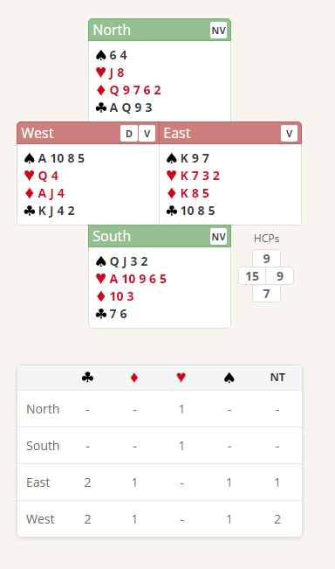
Thursday Bidding Tips 5 Board 16 played on 24/5/2018 Championships 2
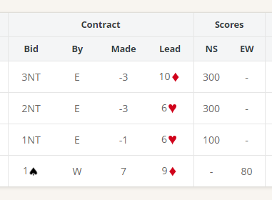

Suggested Bidding 1
N | E | S | W Dealer
 | Pass | Pass | 1C
Pass | 1H | Pass | 1S
Pass | 1NT | All Pass

- Wests bid of 1 Club shows 12-19 points and at Least 4 Cubs.
- Easts reply of 1 Heart shows 6 plus points and a 4 Card Heart suit
- West Bids 1 Spade with a 4-card suit (Must Bid again as change of Suit)
- East Bids 1 No Trump denying 4 Spades and 4 Clubs and showing up to 9 points
- West Passes as if East had 10 plus points they would bid 2 No Trumps.

Suggested Lead from South 6 Hearts (promises an honour and is a signal to North to return the lead)

